**Title: Digital Game Distribution Platform**

**Background description:**

The gaming industry has undergone a remarkable evolution over the past few decades, transforming from a niche hobby into a multi-billion-dollar global entertainment powerhouse. In 2022, the global video game market size was estimated to be USD 217.06 billion dollars and expected to reach USD 242.39 billion by the end of 2023. One crucial element that has fueled this growth is the emergence of gaming distribution platforms. These platforms, such as Steam, Epic Games Store, PlayStation Network, Xbox Live, and mobile app stores, have become the lifeblood of the industry. They serve as digital marketplaces where gamers can purchase, download, and access a vast array of games, often providing developers with direct access to their audience. Gaming distribution platforms have not only made gaming more accessible but have also facilitated updates, patches, and the delivery of additional content, ensuring that games can evolve and remain engaging over time. Furthermore, they have empowered independent developers to reach a global audience, democratizing game development and contributing significantly to the industry's exponential growth [1].

**Problem Description:**

Bangladesh is also experiencing a radical change. Many Indie game developers and game studios have already entered this market, and others are showing interest too. Unfortunately for Bangladesh, despite having good game studios already in the country, there are no game distribution platforms. Also, joining the already-present platforms like Steam and Epic Games is nearly impossible for Bangladeshi game developers. For gamers, it is very hard to buy games from these platforms. So, most of the gamers are following many unethical means for buying games or using pirated copies. Losing a big market such as this is a huge downflow to the economy of the country. Making a gaming distribution platform for Bangladeshi Gamers will surely touch the mass gamers who are already trying various ways to buy games and it will surely encourage the already present Bangladeshi game studios and indie developers to join the industry too. The country will finally be able to join the gaming entertainment market and it will surely improve the economy drastically [2].

**Proposed Solution to the problem:**

* + - A software-based application which will be able to distribute games both Online Single/Multiplayer player and Offline Single player games.
    - A web-based version of the application where new users will be able to register, and existing users will be able to login.
    - The software version of the application will allow users to show user information, update information, view new games, buy new games, play games, and review them.
    - Both software and web-based applications will be able to give support to the games developers so that they can efficiently manage their uploaded game through the application.
    - Game servers will be managed by the Distribution platform and will be open 24/7.
    - Both Gamers and developers will be able to buy/sell games in dual (Taka and USD) currency, a solution that is not present now.

**Objective:**

* + - To distribute games developed by both national and international game developers.
    - To distribute games to national and international gamers in dual currency (Taka and USD).
    - Game developers will be able to manage the game library efficiently.
    - Easy Signup process for indie developers.
    - 24/7 support capability.
    - Online Game marketplace both for general and beta testers.
    - Developers should be able to patch/update their games periodically without any extra hassle.
    - Developers/Game studio will be able to launch Game events such as Tournament through the platform.

**Basic Functionality:**

The following are the basic functionalities of both web-based and software-based application for the users that will allow them to:

* + - Login with an existing account or create an account with password.
    - View Games, Up-coming game news, Updates, View game related Events such as international gaming tournaments and so on.
    - For Gamers: Buy games and other games related accessories.
    - For Developers: Sell games, launch new events, and sell other game-related accessories.
    - Choose the form of payment (Preferred bank/Online Banking/Master card/other payment methods)
    - Modify Game libraries.

**Target Audience:**

* + - Gamers who want to buy games and play them.
    - National and International game studio/developers who want to sell games.
    - Alpha/Beta Testers/Developers who test games for finding bugs.
    - Different banking mediums such as BRAC, Dhaka bank etc.
    - Online Banking mediums such as Bkash.

**Requirement Analysis**

**Functional Requirements:**

1. **Software Login**
   1. The software (both web and PC version) will allow users to login with their given username and password.
   2. The login credentials (username and password) will be verified with database records.
   3. If the login successful, the home page of the user account will be displayed.
   4. If the username and/or password has been inserted wrong, the random verification code. will be generated and sent to the user’s email address by the system to retry login.
   5. If the number of login attempts exceed its limit (3 times), the system will block the user account login for one hour.

**Functional Priority: High**

1. **Distribution of Games**
   1. Users (gamers) will be able to buy games with their desired games in dual currency.
   2. Developers (studio) will be able to sell games through the platform to gamers with different types of currency.
   3. The platform will be able to manage the game prices and update them in time to time.
   4. If a game gets a lower rating and gets reported by the gamers it will be given review for 3 months or will be removed from the game library and 100% money will be given back to the buyer.
   5. The price of a game will be set according to the popularity of games and game title and will be managed by the platform.

**Functional Priority: High**

1. **Server Availability and Security Check**
   1. Game servers should be available 24/7 with the lowest latency possible. If a server is jammed with too many users, the platform will open sub servers to reduce the load.
   2. Game servers will be set by the platform automatically. If a user is facing a connection issue the platform will change the server automatically. Also, the user will be given options to change the region too.
   3. If a any suspicious activity is being observed by the server, the platform will cut the connection of the user and re-establish it. If the problem persists the user will be given a shadow ban and will be asked for further clarification.
   4. Any server that has too much ping will be closed, and new server will be opened by the platform immediately.
   5. Game server will always keep a connection to the user while playing games. So that no kind of unethical modifications can be made to the game.
   6. High speed download servers will be provided to the gamers so that they can download/Update the games at high speed.

**Functional Priority: Extremely High**

1. **Game Account Modifications**
   1. Users will be able to modify game libraries.
   2. Users should be able to add new friends to the friends list so that they can play together.
   3. Users will be able to rate/review the game in 3 systems (Stars, Comment, Percentile ranking) this rating will be reflected for future pricing of the game.
   4. Users can give their player user tag as they like. They can either set up their profile as public or keep it anonymous.

**Functional Priority: Medium**

1. **Payment**
   1. Users will be able to pay with different banking systems available in the country. Depending on the Banking system and their payment method not all Banks will be available on the platform.
   2. Users will be able to pay with online Banking systems such as Bkash, Nagad.
   3. If a user has MasterCard, he/she will be able to pay with it too.
   4. Other popular payment systems will be available in the platform too.
   5. All Payment credential (Account holder name, account number etc.) will be available with relevant selected payment method partners database records.
   6. If the payment is successful, the system will generate the requested purchase almost instantly.
   7. If the payment is unsuccessful due to any sort of issue, the user will get maximum 24 hours to complete the payment to confirm the purchase otherwise purchase request will be canceled.
   8. All Payment records will be hidden. Only the account holder and the platform will be able to access the records.
   9. The platform will not charge any hidden cost. What is shown is what will be paid by the user.
   10. All payment procedures will be processed almost instantly so that users won’t have to wait for the game to play.
   11. If a user doesn’t find any game worth playing, he/she will be able to refund 100% of the money within 24 hours of purchasing time.

**Functional Priority: Extremely High**

**Non-Functional Requirements:**

1. **Scalability:** The platform will be able to handle large numbers of users and game uploads, with the ability to scale resources as the user base grows.
2. **Performance:** All games will download and run quickly, and the platform will have minimal downtime and responsive user interface.
3. **Security:** User data will be encrypted and protected from fraud and hacking, with regular security audits and updates.
4. **Reliability:** The platform should be highly available and reliable, with regular backups to prevent data loss.
5. **Usability:** The user interface should be intuitive, user-friendly, and accessible to a wide range of users.
6. **Compatibility:** The platform should work smoothly on various hardware and software configurations, ensuring a consistent user experience.
7. **Legal Compliance:** The platform must adhere to relevant copyright and intellectual property laws, as well as regional legal requirements for game distribution.
8. **Regulatory Compliance:** Compliance with data protection and privacy regulations is a must, such as GDPR, to safeguard user data.
9. **Monetization and Revenue Model:** A clear revenue model, such as commission on game sales, should be established for the platform's sustainability.
10. **Data Analytics:** User data must be collected and analyzed to improve the platform and enhance recommendations.
11. **Backup and Disaster Recovery:** Implementation of robust backup and disaster recovery plans should be taken in to mind to ensure data and service continuity.
12. **Documentation:** Maintaining comprehensive technical documentation for developers and administrators is needed to support ongoing development and maintenance.
13. **APIs and Integration:** APIs for third-party integration and support should be given for game developers to extend the platform's capabilities.
14. **Load Testing and Performance Optimization:** load testing and continuous optimization needs to be conducted frequently for the platform's performance to ensure it can handle user demand and run efficiently.

**Pre-requisites:** To successfully integrate and fulfill the functional and non-functional requirements for the game distribution platform some important pre-requisites need to be integrated first, so that all the above-mentioned can be fully integrated.

1. **High Performance Server:** The availability and performance of the Game distribution platform depends on the servers handling capacity and speed. With a high-performance server gamers and developers will be able download and push games efficiently without delay.
2. **Good Payment gateway:** The platform needs to Partner with secure and reputable payment gateways for processing transactions, ensuring users can make payments with confidence.
3. 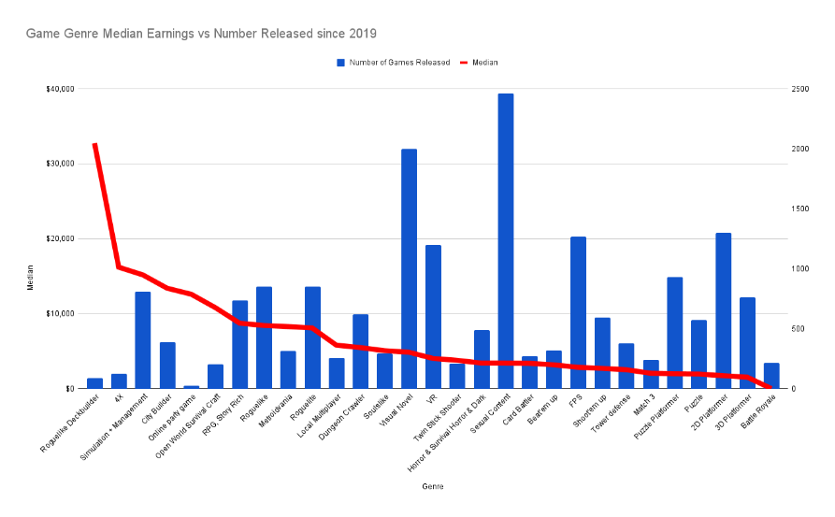**Market Research:** In-depth market research is essential to identify user preferences, competitors, and trends in the gaming industry. This research will help shape your platform's features and capabilities.

Fig 1: Genre releases and Yearly revenue of games [3].

The distribution platform needs to focus on games that are hugely popular and have a better revenue on the market. From Fig 1, Games such as “RPG and Story” type games have good popularity and the market shares for such games are also high. Second to that “Rougelike” games are also popular and have a good revenue on the market. Also, the number of releases of these games are also high.

To create a successful Game Distribution Platform, **“It's essential to earn a place in gamers' hearts”**. While revenue may not always be the immediate goal, catering to niche or less popular games that have a dedicated community (Battle Royals, VR from the Bar graph) can help build loyalty among gamers. This loyalty can be a key factor in establishing a sustainable and trusted distribution platform.

Conclusion: The platform will include games on 4 points.

1. Popularity
2. Market Revenue
3. Number of game Releases per year
4. Non-popular games with dedicated community
5. **Secured Database:** It is one of the most important parts of the Distribution platform. A secured database will ensure the safety of important data for gamers and developers also it will prevent any data breaches that might happen when the platform gains popularity.

**SDLC: XP (Extreme Programming) Model**

**Why choose XP model:** Extreme Programming is a type of agile software development model known for its focus on collaboration, customer feedback, and flexibility. It was created by Kent Beck in the late 1990s and has gained popularity for its customer-centric approach to software development. For this project, the most crucial aspect of XP is its collaborative nature. XP fosters close teamwork among developers, testers, and customers, ensuring open communication and a shared understanding of requirements. This collaborative environment is invaluable for gathering frequent customer feedback, allowing us to stay attuned to market demands, stay on the right path and deliver a competitive software solution. Moreover, XP's iterative model with timeboxed deliveries aligns well with our project goals, providing predictability in release schedules and the flexibility to adjust to changing market conditions. This combination of customer focus, collaboration, and adaptability makes XP an ideal choice for our project. Some of the good practices that have been recognized in the extreme programming model and suggested to maximize their use are given below:

1. **Iterative and Incremental Development:** XP promotes short development cycles, typically one to three weeks long. During each cycle, a small part of the software is developed and tested. This iterative and incremental approach allows for frequent releases and quick feedback.
2. **Test-Driven Development (TDD):** Developers write automated tests before writing the code. This helps ensure that the code meets the specified requirements and continues to function correctly as changes are made.
3. **Pair Programming:** Developers work in pairs, with one writing the code and the other reviewing it in real-time. This practice promotes collaboration and knowledge sharing. Both developers brainstorm to provide higher-quality code.
4. **Simplicity:** XP encourages keeping the software as simple as possible. Unnecessary complexity is avoided, and the focus is on delivering valuable features efficiently.
5. **Refactoring:** Developers regularly restructure and remove duplicate parts from the code to improve its structure, readability, and maintainability. Refactoring is an essential part of keeping the codebase healthy.
6. **Collective Code Ownership:** Team members share responsibility for the entire codebase, which promotes collaboration and reduces bottlenecks. That means anyone can change the code, it encourages new changes without bottlenecks.
7. **On-Site Customer:** Ideally, a customer representative is physically present with the development team to provide immediate feedback and clarify requirements. Though physical customer present is a good thing but for this case gamers/game studio will be considered as beta testers and for every release they will be given a portion of time to test the software before its public release and the whole process will be fully online.
8. **Continuous Integration:** Code changes are integrated into the main codebase frequently, often multiple times a day. Automated tests are run to detect integration issues early.

**Conclusion:**

The main goal is to deliver a competitive Game Distribution Platform which can compete with the already well-developed Platform in the marketplace. So, customer involvement, frequent release, timeboxed development, frequent feedback is the best way to develop such software. Also, XP usually works for small (up to 10) team-based development projects, which is a good practice for this project. Keeping the team size small, reduce communication errors, closer collaboration, and more efficient decision-making process. With a tightly-knit team, it's easier to maintain a shared vision, quickly adapt to changes, and ensure that everyone is on the same page regarding project objectives.

Also, XP is model for projects involving new technology or Research. Which aligns with the project’s goal of creating a Game Distribution Platform different from already present Platforms, making it a suitable choice to deliver a high-quality and competitive software solution.

**Change in Development Model:** While Agile's XP model can be effective during the initial development stages of the platform, it's crucial to consider a change in the development approach after the public release. A gradual transition toward models like Feature-Driven Development (FDD) and Dynamic Systems Development Method (DSDM) may become necessary for long-term sustainability.

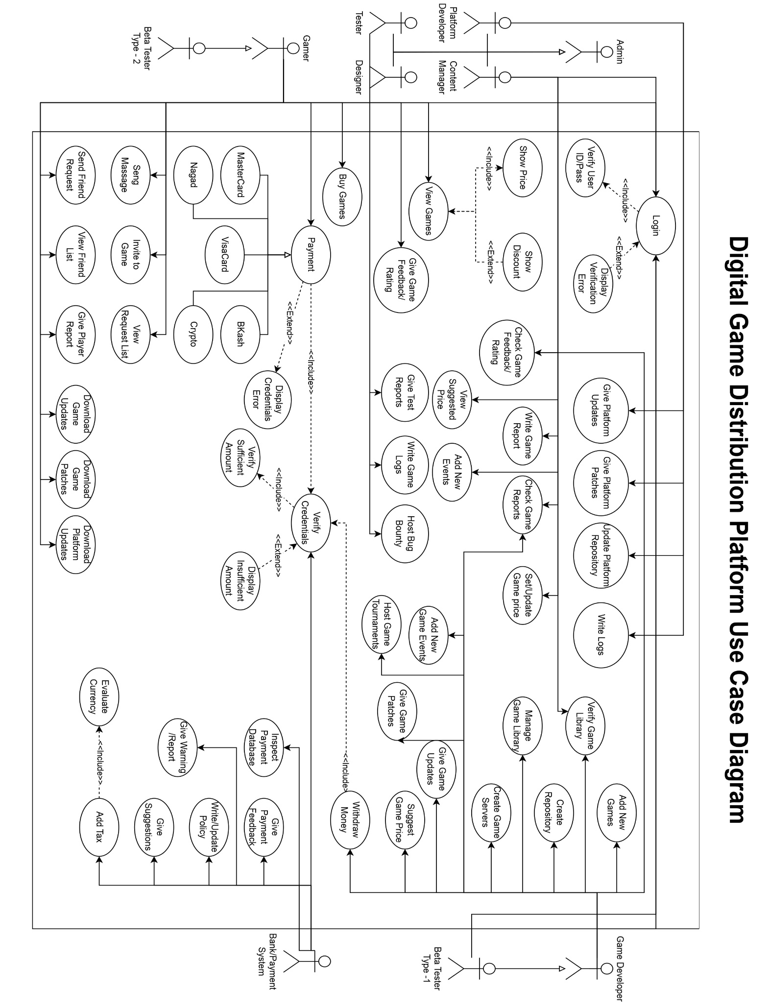**UML Diagram -1 (Use Case)**

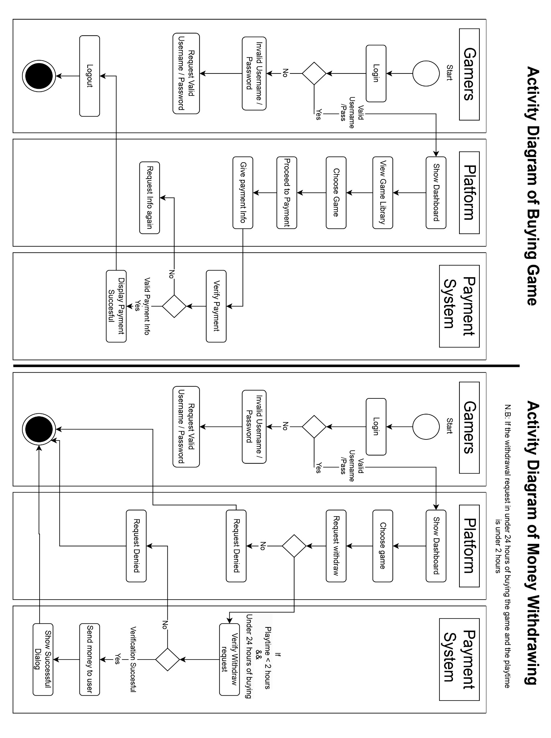**UML Diagram -2 (Activity)**

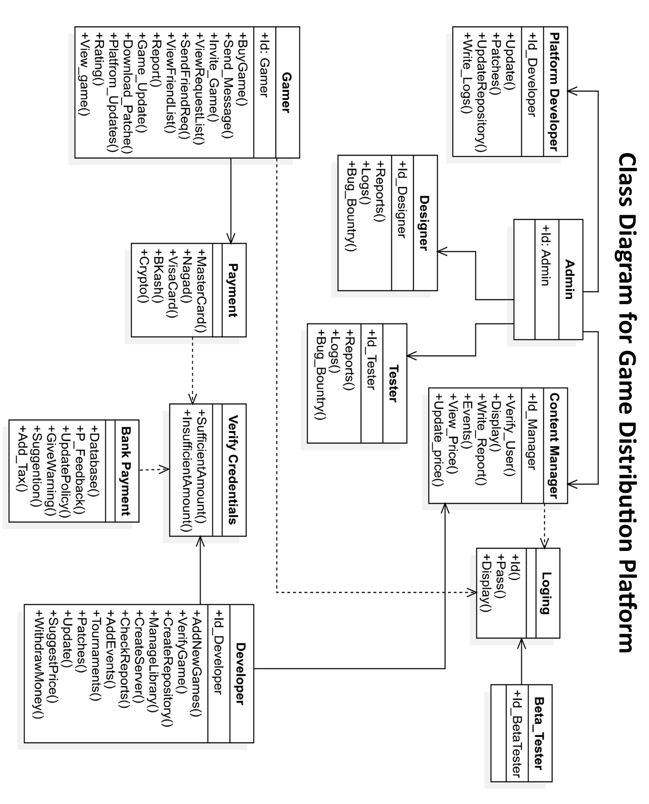**UML Diagram -3 (Class)**

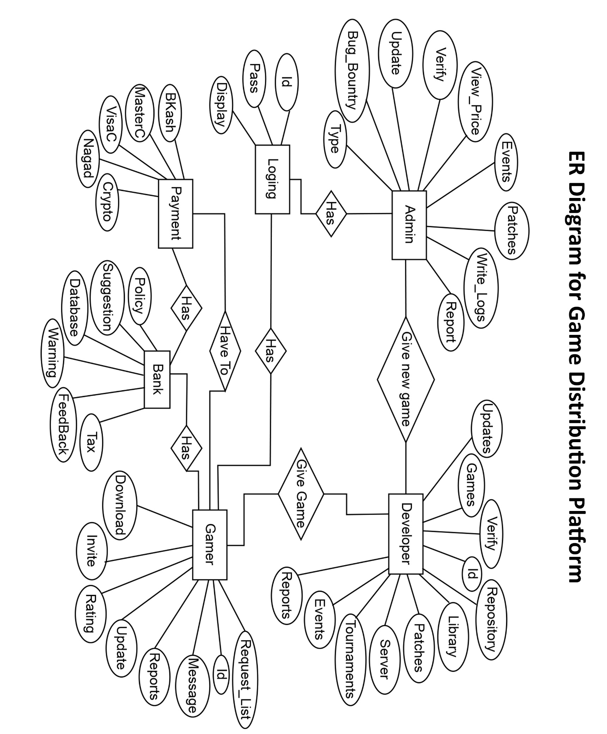**UML Diagram – 4 (ER)**

Sources:

1. <https://www.grandviewresearch.com/industry-analysis/video-game-market>

2. [https://www.thedailystar.net/tech-startup/news/made-bangladesh-how-the-local-video-games-industry-levels-3411656](https://www.thedailystar.net/tech-startup/news/made-bangladesh-how-the-local-video-games-industry-levels-3411656%20)

3. <https://howtomarketagame.com/2022/04/18/what-genres-are-popular-on-steam-in-2022/>